Join our mini-BIOBLITZ
We need your help to see how well these 10 things are doing in the Tayside area. Use this sheet to record where and when you see them at any time up to the 13th August – or put your findings onto the website (details below). Use the back of this sheet for multiple recordings.
Song Thrush | House Sparrow | Brown Hare | Hedgehog
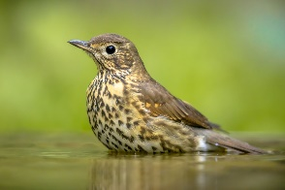 | 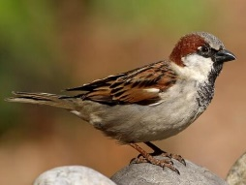 | 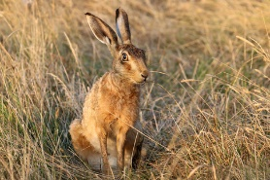 | 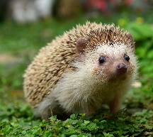
When:  Where: | When:  Where: | When:  Where: | When:  Where:
Slowworm | Carder Bumble Bee | Red Admiral | Ragged-Robin
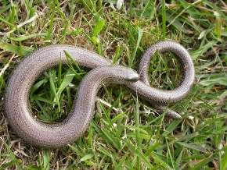 | 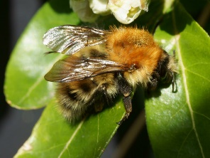 | 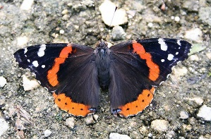 | 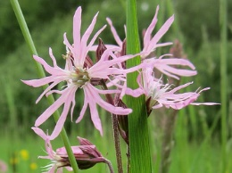
When:  Where: | When:  Where: | When:  Where: | When:  Where:
Oxeye Daisy | Harebell | DAVIE PARK ACTIVITY AFTERNOON  Friday 21st July 2023  Come and join in the fun at our activity afternoon in Davie Park. Meet by the raised beds near the Pond any time between 2pm and 4pm to help search for evidence of any of these 10 species – and also to see what else you can discover.
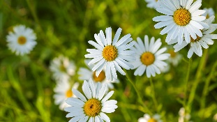 | 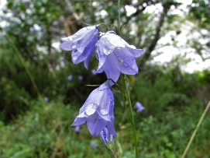
When:  Where: | When:  Where:

Hand in your sheet at: Davie Park on the 21st or at the BARI zero waste food shop anytime up to the 13th August or put your observations on the web yourself by going to ‘https://www.inaturalist.org/projects/biodiversity-village-communities-mini-bioblitz-blairgowrie-rattray’ and logging in as ‘bioblair’ with the password ‘Bl@1rg0wrI3’ (or create your own account if you wish). Once there, click on projects to get to the Blairgowrie and Rattray page.

