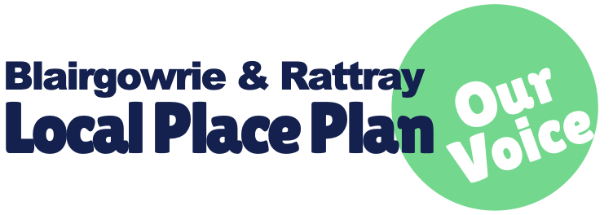

Your name & email address is optional:

————————————————

Survey

To inform our Local Place Plan we need your views to make sure it communicates the community’s aspirations and needs to make Blairgowrie & Rattray a better place to live, work and visit. The Local Place Plan will help to shape Local government’s Local Development Plan (LDP3) and decision making for the land-use in our area.

1. What is missing in Blairgowrie and Rattray?
2. Where on the map would you locate what you think is missing?
3. Is there any building or any space in Blairgowrie & Rattray you feel could be adapted to be of better use?

a) What?

b) Where?

c) How could it be adapted or better used?

1. What do you see as location-based issues?
2. How can we as a community look to resolve the location-based issues?
3. Do you know any contacts that we could be in touch with to help inform this local place plan? Please add their name and email below.

Name: Email:

* Continue overleaf if necessary.
* Email completed survey to [admin@brdt.org](mailto:admin@brdt.org) or drop off at the BARI Building.